The Client plays against someone on the Server  
  
Architecture

Client Chess 1

Client Chess 2

gRPC

gRPC

Server Chess

Entity Framework

EF

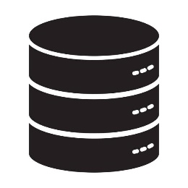

Server

Client1

Client2

Send Start Game Response

Receives Start Game Responseuest

Initialize Game

Receives Game Request

Start Game Request

Game Initialization

rpc StartGame

c

rpc StartGame

c

Game

Send Move

Receives Move

Rpc VerifyMove

c

rpc MakeMove

c

v

rpc StreamGameUpdates

c

Validates Move

Updates Board

Receives move from opponent move Request

Asks if opponent made move Board

rpc MakeMove

c

rpc StreamGameUpdates

c

Send Move

Receives Move,  
Verifies Move,  
Updates Board

rpc StreamGameUpdates

c

Sends Updates

Rpc VerifyMove

c

Send Move

…

Sets game as finished

Rpc EndGame

c

Ends Game

Sends all moves played

Rpc GetAllMoves

c

wanna to see moves?